Quản lý lịch bay

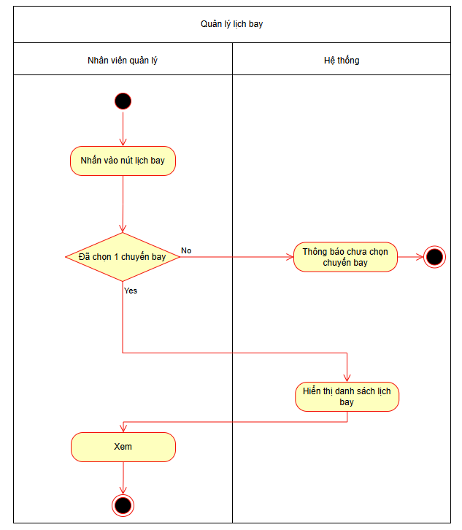

Thêm khung giờ bay

Chọn máy bay

Thiết lập giá vé

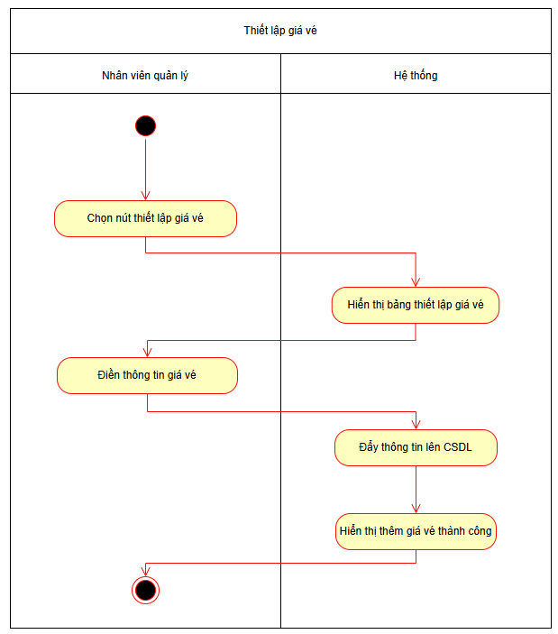

Tìm kiếm chuyến bay

Lọc chuyến bay

